1. 
2. **Agenda**:
   1. How to extract and display data within a specific array range.
3. [**FROM** : **TO**]   
   Starting Index = **FROM**, Ending Index = Ending Index exclusive.  
   If **FROM** is missing then by default it is Zero [:3]  
   if **TO** is missing then by default it is arrayLength [:2]
4. 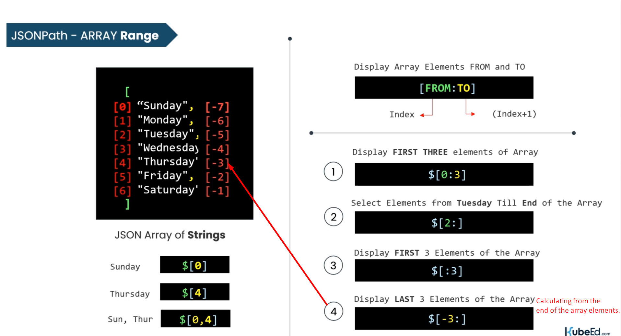   
   Till now, we learnt how to select continuous elements from an array within a specific range.  
   But there are some scenarios where you need to select elements in some irregular intervals.   
   Graphical user interface

   Description automatically generated
5. Let’s move on to the jsonpath.com  
   A picture containing text

   Description automatically generated  
   Graphical user interface

   Description automatically generated